Maroun choufany

Database diagram:

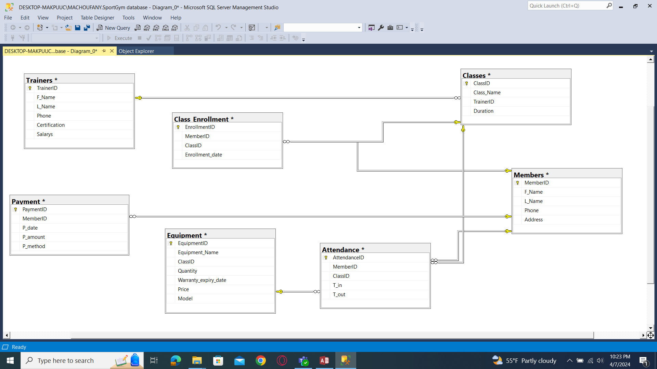

1. Tables with constraints:

create table Members(

MemberID int identity primary key,

FirstName varchar(50) not null,

LastName varchar(50) not null,

Phone varchar(20),

Address varchar(100)

);

create table trainers(

TrainerID int identity primary key,

FirstName varchar(50) not null,

LastName varchar(50) not null,

Phone varchar(20),

Certification varchar(100),

Salary Money check(salary>=0),

);

create table classes(

ClassID int identity primary key,

ClassName varchar(50) not null,

TrainerID int references trainer(trainerID) not null,

Duration varchar(50),

);

create table Equipment(

EquipmentID int identity primary key,

EquipmentName varchar(50) not null,

Quantity varchar (20),

Price money check(price>=0),

Model numeric(20),

);

create table Class_Enrollment(

EnrollmentID int identity primary key,

MemberID int references member(memberID) not null,

ClassID int references class(classID),

Enrollment_date date, check(Enrollment_date<=getdate()),

);

create table Attendance(

AttendanceID int identity primary key,

MemberID int references member(memberID),

ClassID int references Class(ClassID),

T_in varchar(50),

T_out varchar(50),

);

create table Payments(

PaymentID int identity primary key,

MemberID int references member(memberID),

Payment_date date check(payment_date<=getdate()),

Payment_amount money check(payment_amount>=0),

Payment_method varchar(50) not null,

);

SQL Statements:

1. Query with criteria and sorting result:

Select firstname,MemberID

From Members

where Address in('rmeish')

order by MemberID

1. Query using aggregate function:

select avg(salary)

from trainer

1. Query using aggregate function and having:

select equipmentname ,avg(price)

from Equipment

group by equipmentname

having avg(price)>100

1. Queries using set operators:

select EquipmentID

from Equipment

where quantity='10' and model=2015

union

select equipmentID

from Equipment

where quantity='15' and model=2020

select EquipmentID

from Equipment

where quantity='30' and model=2020

except

select equipmentID

from Equipment

where quantity='9' and model=2020

select EquipmentName

from Equipment

where quantity='10' and model=2014

intersect

select EquipmentName

from Equipment

where quantity='35' and model=2015

1. Query with subquery:

select EquipmentName

from Equipment

where price>(select avg(price) from Equipment)

1. Query using Not exsits:

select distinct memberID , firstname

from Member

where not exists(select classID

from class

where ClassName='kick-boxing')

1. 1 View of your choice:

create table archive(

MemberID int,

FirstName varchar(50),

payment_amount decimal(20,0),

payment_method varchar(50) ,

);

insert into archive

SELECT dbo.Payments.MemberID, dbo.Member.FirstName, dbo.Payments.Payment_amount, dbo.Payments.Payment_method

FROM dbo.Member INNER JOIN

dbo.Payments ON dbo.Member.MemberID = dbo.Payments.MemberID

GROUP BY dbo.Payments.MemberID, dbo.Member.FirstName, dbo.Payments.Payment_amount, dbo.Payments.Payment_method

1. 3 Queries using update , insert and delete:

update trainer

set Salary=Salary*1.1

where Salary>100

insert into Member

value 'maroun','choufany', 76762909, 'rmeish'

delete

from trainer

where Salary<400